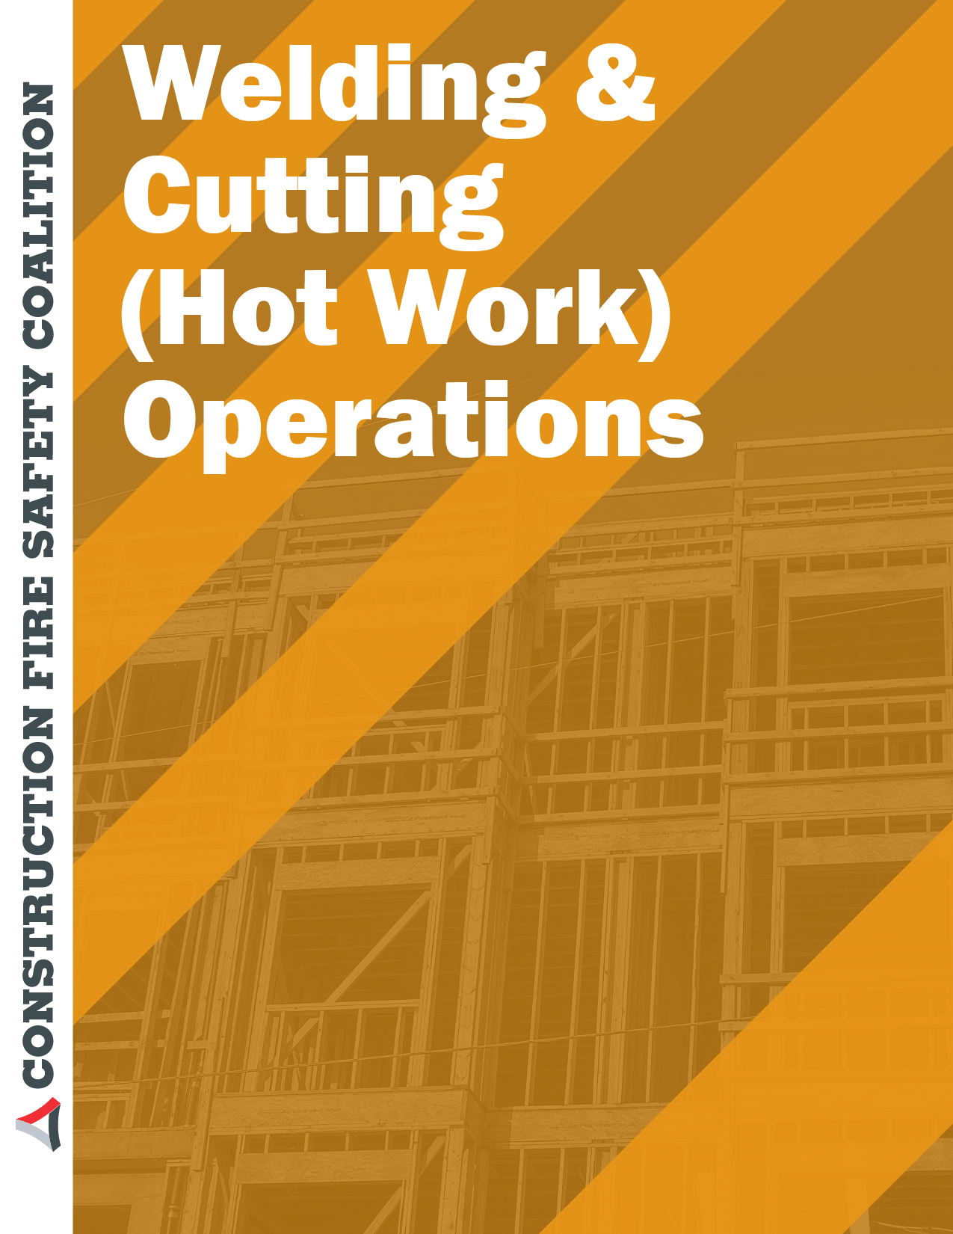

Welding and Cutting (Hot Work) Operations Self-Audit Checklist

Building
Room
Supervisor
Date

Audit Performed by
 | Y | N | NA | COMMENTS
A. General Welding and Cutting Controls
1. Welding and cutting operations restricted to authorized employees
2. Fire Code Permit obtained
3. Hot work performed in a shop area, if possible
4. Combustible materials moved at least 35 feet from worksite
5. Floor and wall openings covered at least 35 feet from worksite
6. Procedures developed to prevent welding and cutting in the presence of explosive or toxic air contaminants
7. Fire resistant curtains and/or tinted shields provided
8. Local or general exhaust ventilation adequately used
9. Appropriate personal protective equipment provided and used
10. Appropriate fire extinguishers provided in vicinity of hot work
11. Building sprinkler systems operational, when applicable
12. Procedures developed to establish and maintain a fire watch in hot work areas
13. Hot work permit used

General Welding and Cutting Controls

- Welding and cutting operations should be restricted to workers who have been properly trained.

- Fire code permits are required for all welding and cutting operations. Permits are obtained from the local fire official.

- Whenever possible, hot work should be performed in a properly designed shop area equipped with all necessary controls and adequate ventilation.

- Combustible materials, such as building construction materials or other building contents, must be located at least 35 feet from the hot work area or properly protected to prevent hot sparks from contacting them. Floors within this area must also be swept clean of all combustible materials.

- All openings in floors and wall within 35 feet of the hot work area must be covered to prevent hot sparks from entering walls or falling beneath floors or to a lower level.

- Hot work should not be conducted in the presence of explosive mixtures of flammable gases, vapors, liquids, or dusts or where explosive mixtures could develop inside improperly prepared tanks or equipment. Atmospheric testing and monitoring for combustible gases and vapors should be conducted before work begins and at predetermined intervals thereafter.
- Fire resistant curtains and tinted shields should be used to prevent fire, employee burns, and ultra-violet light exposure.

- Self explanatory

- Personal protective equipment specifically designed for hot work should be provided to and used by workers. Potential for material being worked on or surface coatings to emit toxic fumes should be considered.

- A fire extinguisher rated at not less than 2-A:20-B:C must be available in shop areas where hot work is performed. A fire extinguisher rated at not less than 2-A:10-B:C must be attached to all portable welding carts. Contact EHS for additional guidance in fire extinguisher selection.

- The building’s sprinkler system, if so equipped, must be operational before hot work can begin.

- A person other than the operator should perform fire watch duties and should remain at the worksite for at least 30 minutes after hot work operations have ended.

- A written hot work permit can serve as a checklist for operators and helps minimize the risk of fire from such activities. Contact EHS for a model written permit or additional guidance in establishing a hot work program.

 | Y | N | NA | COMMENTS
B. Welding or Cutting in Confined Spaces
1. Procedures developed for confined space entry and rescue
2. Ventilation and/or respiratory protection provided
3. Welding and cutting equipment left outside space
4. Electrodes removed from holders and/or gas supply shut off when operations are suspended for any substantial period
5. Hot work permit used
C. Compressed Gas Cylinders
1. Oxygen and fuel gas cylinders stored separately with protective value caps in place
2. Regulators compatible with gas cylinder
3. Cylinder carts used for transport
4. Cylinders secured from tipping while in use
5. Empty or unused gas cylinders promptly returned to supplier
D. Training
1. Workers trained in use of welding and cutting equipment, material hazards, and control methods
2. Personal protective equipment training provided
3. Confined space entry training provided, where necessary

Welding or Cutting in Confined Spaces

  - A model confined space entry program is available through EHS.

  - When working in poorly ventilated spaces, exposure to air contaminants generated by welding or cutting must be controlled by ventilation, respiratory protection, or a combination of the two.

  - Gas cylinders and welding machines must be left outside the space when work is performed in spaces such as boilers, tanks, or pressure vessels. Heavy portable equipment mounted on wheels must be securely blocked to prevent movement.

  - A substantial period of time can be defined as lunch breaks or longer. Procedures are spelled out in the model confined space program available through EHS.

  - A written hot work permit should be used for all hot work operations. Sample permits are available through EHS.

Compressed Gas Cylinders

  - Except when in use, oxygen and fuel gas cylinders must be stored separately, at least 20 feet apart or separated by a noncombustible wall at least 5 feet high.
  - Many regulators are similar in design and construction. Ensure that regulators are designed for the cylinder used by checking the manufacturer’s model number and comparing that with the gas supplier’s requirements.

  - Self explanatory

  - Cylinders should always be secured in an upright position. Information is available through EHS on methods for securing cylinders.

  - Self explanatory

Training

  - Workers should be trained in proper equipment operation, handling and storage of welding materials, compressed gas safety, chemical hazards, and in working procedures including the written hot work permit. Assistance in employee training is available through EHS.

  - Workers must receive training on personal protective equipment selection and use. Documentation of the training must be maintained. Sample forms and general training are available through EHS.

  - Workers must receive training before working in confined spaces. General training is available through EHS.

