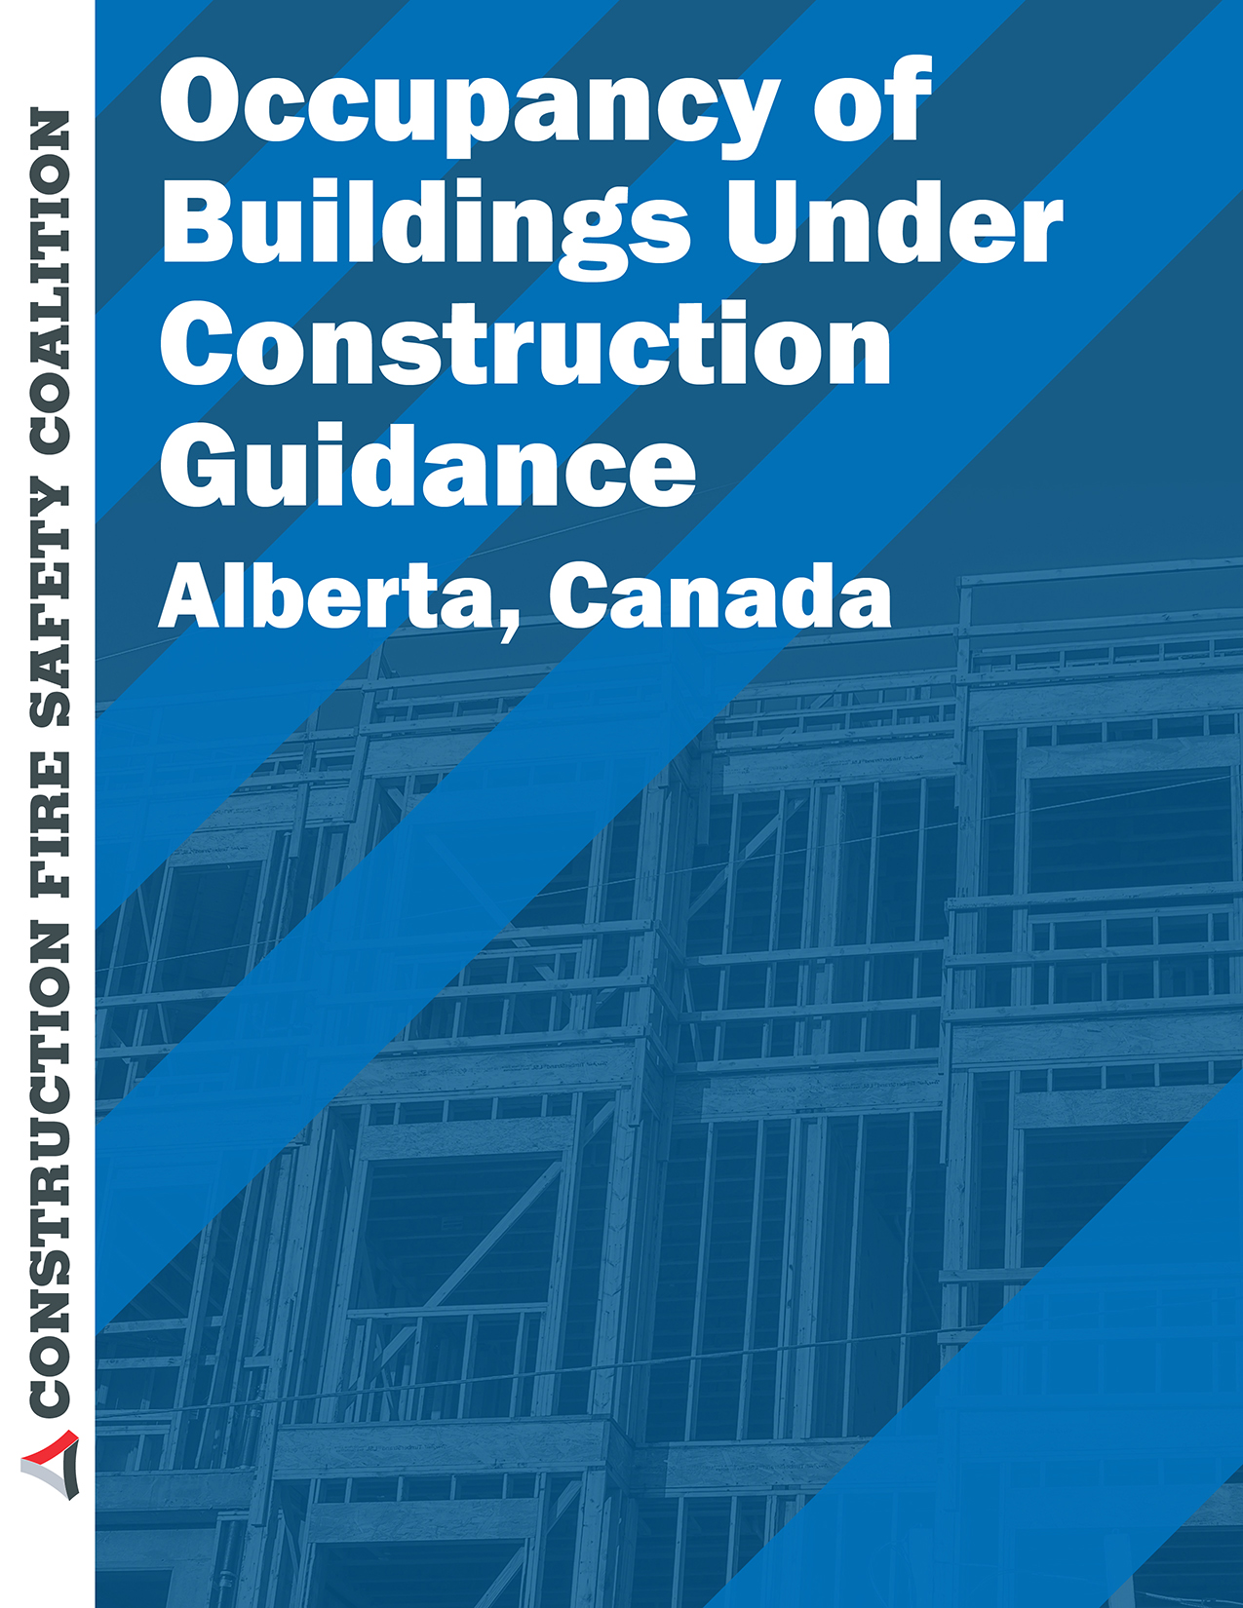

BUILDING/FIRE CODE

N
BULLETIN
March 2018 14-BCB-004
14-FCB-003
Page 1 of 4

OCCUPANCY OF BUILDINGS UNDER CONSTRUCTION

PURPOSE
This bulletin was developed to provide guidance for determining when occupancy of a building under construction may be allowed.

DISCUSSION
Sentence 2.2.11.2.(1) of Division C of the Alberta Building Code 2014 (ABC 2014) allows for an authority having jurisdiction (AHJ) to issue an occupancy permit for a building before construction is actually finished. This can occur in a number of situations including:
  - Buildings constructed and occupied in phases;
  - Additions or alterations to the building where the completed areas of the building remain in use or are occupied.
Sentence 8.1.1.1.(3) of ABC 2014 specifies that fire safety at construction and demolition sites shall conform to the requirements in Section 5.6. of Division B of the Alberta Fire Code 2014 (AFC 2014), this in turn requires the development of a fire safety plan. This fire safety plan should be developed in consultation with the local fire department or fire prevention personnel.
All building services, including those services for fire safety, boilers and pressure vessels, elevating devices, and gas, plumbing, mechanical and electrical systems, must be considered when determining the provisions required to safeguard the occupants of a building. To assist safety codes officers and other persons with this activity, a checklist is provided below. Some of the items on this checklist may only apply to specific construction situations.
- The fire safety plan required by Section 5.6. of Division B of the AFC 2014 and Sentence 8.1.1.1.(3) of the ABC 2014 for buildings and portions of buildings under construction shall be adapted to include provisions for the occupants and the workers to the satisfaction of the fire and building AHJ.
- The structure and enclosing walls of the building are complete up to and including the roof.
- The walls enclosing the space to be occupied are complete.
- All guards for balconies are complete.
- Stair shafts are complete for the full height of the building, including all doors between the stair shafts and adjacent floor areas.
- The fire elevator in high rise buildings is operational for all storeys up to and including the one to be occupied. The barrier-free elevator or platform-equipped elevating device is operational for all storeys up to and including the one to be occupied. STANDATA 14-BCI- 018 Elevator Operations and Accessibility
- All fire separations and closures are complete on all storeys up to and including the storey to be occupied.

Unless stated otherwise, all Code references in this STANDATA are to Division B of the Alberta Building Code 2014.

Alberta Municipal Affairs – Community & Technical Support, 16th Floor, 10155 –102nd Street, Edmonton, Alberta, Canada, T5J 4L4 Phone: 1-866-421-6929 Email: safety.services@gov.ab.ca Website: www.municipalaffairs.alberta.ca
Issue of this STANDATA is authorized by
the Provincial Building and Fire Administrators
[Original Signed]
Paul Chang
[Original Signed]
Tina Parker

- Exits and accesses to exit are complete including fire separations, doors, door hardware, self-closing devices, guards and handrails from the uppermost storey to be occupied down to the level from which occupants will exit the building (or the lowest level in the basement up to the exit level if the exit serves the basement). Means of access to the building may need to be enclosed to protect the building occupants from falling objects.
- All aspects of barrier-free design outlined in Section 3.8. shall be completed for all areas intended to be occupied.
- If service rooms are in operation, fire separations around the service rooms are complete and closures are installed.
- All service shafts, including closures, are complete to the floor/ceiling assembly above the storey to be occupied and have a fire separation at that assembly.
- Water supply, drain, waste and vent systems are complete and operational for all storeys up to and including the one to be occupied. Plumbing vent systems should be completed. All unused openings in waste pipes must be effectively capped off.
- Electrical systems and equipment on each occupied floor are complete and operational. CO/Fire Alarm/detector devices and other related electronic devices should not be installed in a “construction zone” where dust can get into the electronics and reduce life span, or impair proper operation.
- Emergency power supply systems are installed, operational and connected to the equipment and appliances requiring emergency power supply. These systems shall be maintained throughout the duration of construction. Lighting in corridors, exits and stairwells is complete for all storeys up to and including the one to be occupied.
- Standpipe, sprinkler, fire alarm and detection systems are complete and operational for all storeys up to and including the one to be occupied and exterior connections for fire department use are installed and operational. Standpipe systems for firefighting on all unfinished floors are operational. Standpipe, sprinkler, fire alarm and detection systems shall be maintained throughout the duration of construction on all occupied floors.
- Garbage rooms, chutes and ancillary services are complete and operational for all storeys to be occupied.
- Firefighting access routes around the building are provided and accessible.
- Floors, halls, corridors, lobbies and means of egress are free of construction materials and other hazards.
- Outside stairways and walkways are complete to all exits and entrances.
- Security items such as panic hardware and electromagnetic locks are installed at all exits and entrances.
- Mechanical systems such as heating, ventilating and air conditioning systems serving occupied areas are complete and operational.
- If smoke control measures are required by ABC 2014, the measures are complete and operational for all floors to be occupied, including floors designated as areas of refuge.
- Measures are taken to prevent access by unauthorized persons to parts of the building and site that are incomplete.
- Finishes in food establishments, dairy plants and abattoirs are complete.
- Sanitary facilities are in place and functional in all areas being occupied.
- Swimming pool circulating systems in the area to be occupied are complete and operational.
- Other applicable authorities’ approval (Health, Agriculture, etc.) may be required for partial occupancy.
- Submission of professional C-Schedules for partial occupancy.
Boilers and Pressure Vessels, Electrical, Elevator, Fire, Gas, and Plumbing disciplines may provide confirmation to the Building AHJ stating that the preceding applicable safeguards are

adequate and have been satisfied before permitting the use of the building or the building services by other than the constructor or subcontractors for the project.
It should also be noted that Sentence 2.2.11.1.(2) of Division C of ABC 2014 states that the occupancy permit issued by the AHJ does not operate as a license to carry on any intended business function within the building. It is the responsibility of the owner to obtain all necessary permits and licenses prior to commencing any commercial operations on the premises.
Notwithstanding any of the preceding, the Building and Fire AHJ may accept alternate arrangements that, in their opinion, satisfy the safety requirements of the ABC 2014 and the AFC 2014.

CODE REFERENCES
- ABC 2014 Sentence 2.2.11.1.(2) of Division C states:
2.2.11.1. Occupancy Permit
…
2) An occupancy permit or permission to use a building issued under the Safety Codes Act shall not be construed to be a licence to operate or engage in any business.
- ABC 2014 Article 2.2.11.2. of Division C states:
2.2.11.2. Occupancy before Completion
- The authority having jurisdiction may issue an occupancy permit, subject to compliance with provisions to safeguard persons in or about the project, to allow the occupancy of a building before completion of the project.
- The owner shall ensure that no unsafe condition exists or will exist because of construction or work being undertaken or not completed should occupancy occur before the completion of the construction or work.
- Sentence 8.1.1.1.(3) states:
8.1.1.1. Scope
…
3) Fire safety at construction and demolition sites shall conform to Section 5.6. of Division B of the Alberta Fire Code 2014.
- AFC 2014 Article 5.6.1.1. and Appendix A of Division B states:
5.6.1.1. Application
(See Appendix A.)

1) This Section applies to fire safety for buildings, parts of buildings, facilities, adjacent buildings or facilities, and associated areas undergoing construction, alteration or demolition operations.
A-5.6.1.1. The degree of application should be determined in advance in conjunction with the authority having jurisdiction. In construction, alteration or demolition operations that do not pose an exposure hazard to other buildings or to occupants, the degree of application of Section 5.6. may be minimal. The degree of application of Section 5.6. to each operation should be determined in advance, as part of the fire safety plan for the operation, taking into consideration such issues as the size of the operation, exposure of adjacent buildings or facilities to hazards, and the site conditions. Operations can range from large multi-storey buildings to small single-storey residences and may include additions or alterations to existing buildings. In order to satisfy Sentence 8.1.1.1.(3) of Division B of the ABC, all of the relevant requirements of this Section must be complied

with; in particular, the requirement for a fire safety plan in Article 5.6.1.3. must be addressed prior to the commencement of work.

Disclaimer:

The information in this bulletin is not intended to provide professional design advice. If professional expertise is required with respect to a specific issue or circumstance, the services of a professional should be sought.

