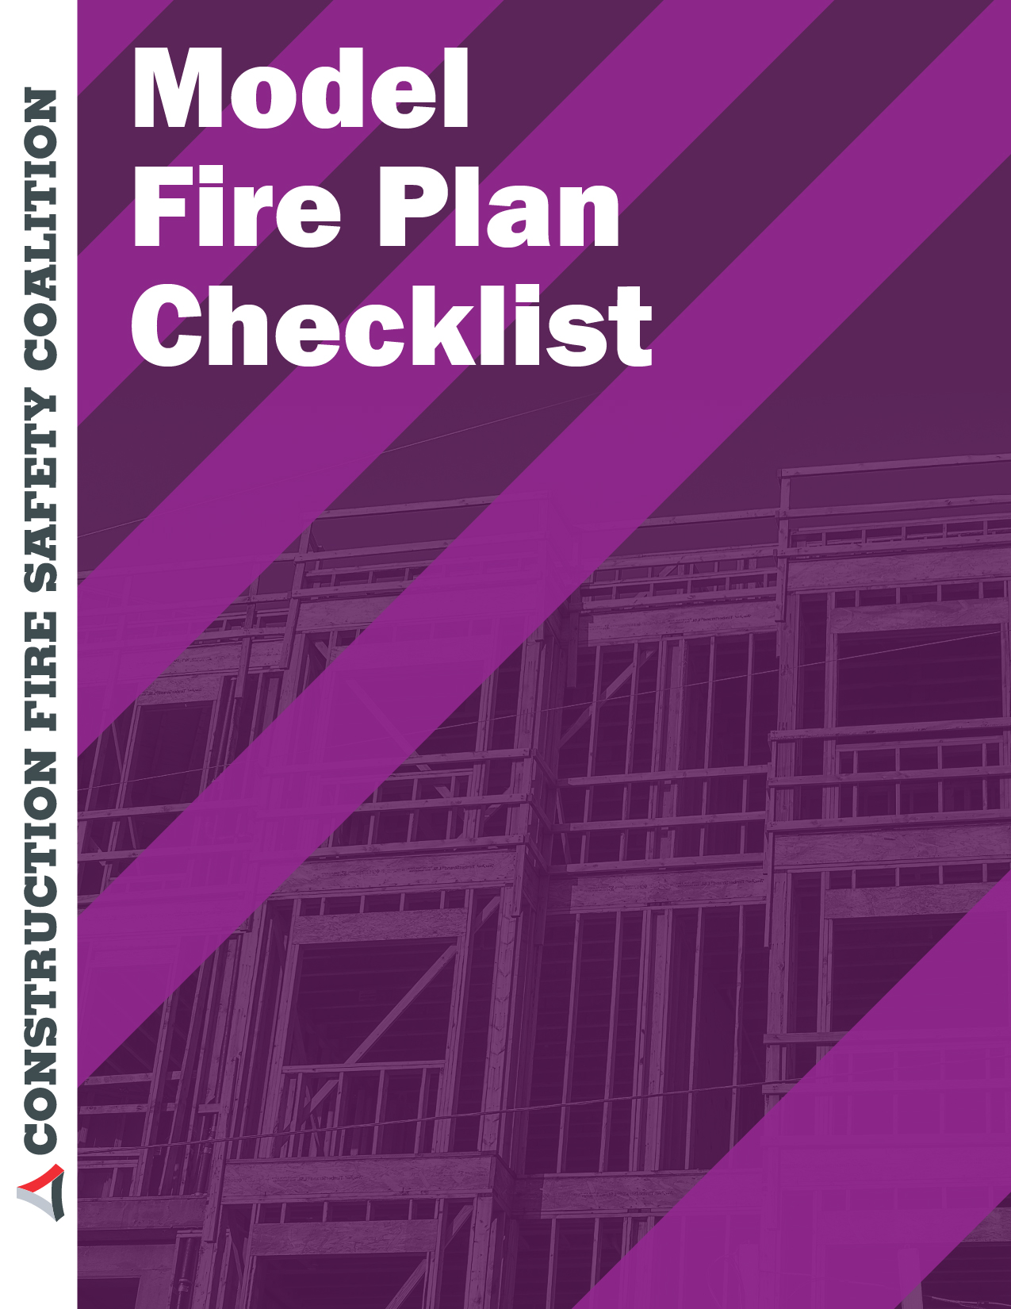

**What are the Contents of an Effective Fire Safety Plan?**

A study of fire safety plans that have already been produced illustrates that one size does not fit all. Depending upon the complexity of a given project, the fire plan may be rather simplified or it could be very complex. That decision can only be made by the fire protection personnel who are involved in evaluating the plan. Conversation between building owners, contractors and members of the fire service representing both fire prevention and operations should result in a plan that is just right for the site.

Please look at the following list as a template for the future and fire protection planning for your site of Name:

Date:

Address of Project:

Building Permit Number:

|  |  |  |  |
| --- | --- | --- | --- |
| **Item** | **Description** | **Acceptable?** | **NA** |
|  | Name and Contact number of the Fire Safety Director: |  |  |
|  | Name and Contact Number of owner, all consultants and contractors: |  |  |
|  | Is there a record of pre-construction meeting with general Contractor and the Fire Department |  |  |
|  | List of Site Personnel |  |  |
|  | Is the Site Address posted and visible from street? |  |  |
|  | Doyou have a Contact Number of closest Hospital |  |  |
|  | Contact Numbers for Emergency Services posted? |  |  |
|  | Do you know where the closest engine company is that would likely respond if you have a fire? |  |  |
|  | Is there a Fire Safety Plan on file for the project? |  |  |
|  | Does the Fire Safety Plan include: Contact names and numbers  Emergency and Critical Phone numbers Objectives of the plan  Duties of Fire Safety Personnel Duties of Floor Wardens?  Directions for occupants, employees and visitors to the site? Building Description and Safety features?  Floor Plans? Evacuation plans? |  |  |
|  | Is a Site Schematic available for the Fire Department? |  |  |
|  | Does it display the following: |  |  |
|  | Existing and proposed Buildings |  |  |
|  | Site Office |  |  |
|  | First Aid and Safety Station |  |  |
|  | | | |

|  |  |  |  |
| --- | --- | --- | --- |
|  | Location of Fire Extinguishers:  are there sufficient numbers on-site?  Are all extinguishers up-to-date, and serviced within the last year. Are extinguishers properly located at or near flammable gases or liquids fueled equipment?  Are they mounted with proper signage, especially within required travel distances.  Are they always available to hot work operations? |  |  |
|  | Location of emergency warning poster for employees |  |  |
|  | Are Hazardous Materials storage locations designated? |  |  |
|  | Location of Emergency shut-offs for Gas and Electric |  |  |
|  | Emergency Vehicle access routes in and out of the site |  |  |
|  | Emergency Exits from site |  |  |
|  | Location of fencing and barricades |  |  |
|  | Designated gathering location |  |  |
|  | Parking for vehicles and delivery trucks |  |  |
|  | Emergency Procedures for fire and emergency events |  |  |
|  | Records of training of on-site personnel |  |  |
|  | Access for firefighting: Hydrants  Fire Department connections for standpipes and Sprinklers |  |  |
|  | Locations of Keys or Key Boxes |  |  |
|  | Locations of all **code required** fire extinguishers |  |  |
|  | Locations of any elevators |  |  |
|  | Location of Primary and Secondary access to the building(s) |  |  |
|  | Provisions for evacuation and egress for personnel |  |  |
|  | Control and Removal of Waste Materials |  |  |
|  | Provisions for Emergency Power |  |  |
|  | Water Supply Plan |  |  |
|  | Records of Site fire Safety Meetings and drills |  |  |
|  | Smoking prohibition |  |  |
|  | Fire Watch procedures. To include: Records of Hot work permit process.  Requirements that area be clear of flammable and combustible materials.  Fire watch assigned for hot work operations in for 60 minutes afterwards.  Final inspection of hot work area for hours after completion.  Keeping hot work away from area were combustible materials have been put in place  Is the hot work being performed by competent and qualified personnel?  Does the hot work operator have its own extinguisher/water bucket.  Proper ventilation being considered? |  |  |

|  |  |  |  |
| --- | --- | --- | --- |
|  | Our hot tar pots operated correctly and properly located and supervised? |  |  |
|  | With regard to flammable and combustible gases and the following considerations been given:  is the storage area separated from all other combustible materials?  Our storage areas lock and properly vented? Is the storage area protected from motorized traffic? Are portable pressurized cylinders secured a near not in use? Does the area have proper/adequate signage in place? Is a recurrent or updated list of dangerous goods on- site are portable extinguishers that are required in close proximity to storage and work areas.  Storage kept out of egress and accessories |  |  |
|  | Standpipe system(s) |  |  |
|  | Fire Warning System |  |  |
|  | Sprinkler systems |  |  |
|  | Compartmentalization |  |  |
|  | Security is being provided? Does the security involve gates, video, area lighting alarms or nightly rounds |  |  |
|  |  |  |  |

Additional Notes:

|  |
| --- |
|  |
|  |
|  |
|  |
|  |
|  |
|  |
|  |

For Reference: You may want to check out these websites as sources of additional; input on your Fire Plan Development.

|  |  |
| --- | --- |
| **1. JPL** | https:[//www.google.com/#q=JPL+Fire+Safety+Plan](http://www.google.com/#q%3DJPL%2BFire%2BSafety%2BPlan) |
| **2. Surrey Fire Service - Construction Fire Safety Bulletin** | <http://www.surrey.ca/files/dct_construction_fire_safety_plan_bulletin_w_form>  _078a.pdf |
| **3. City of Nanaimo Fire safety Plan - Guidelines** | https:[//www.nanaimo.ca/assets/Departments/Fire~Rescue/Fire~Prevention/Ref](http://www.nanaimo.ca/assets/Departments/Fire%7ERescue/Fire%7EPrevention/Ref) 016_Fire_Safety_Plan_Guideline_v1.pdf |
| **4. Beaumont Texas Template** | <http://www.town.beaumont.ab.ca/09/images/file/PDF%20documents/Planning>  %20and%20Development%20Services/Permit%20Applications/Fire%20Safety%2 0Plan.pdf |