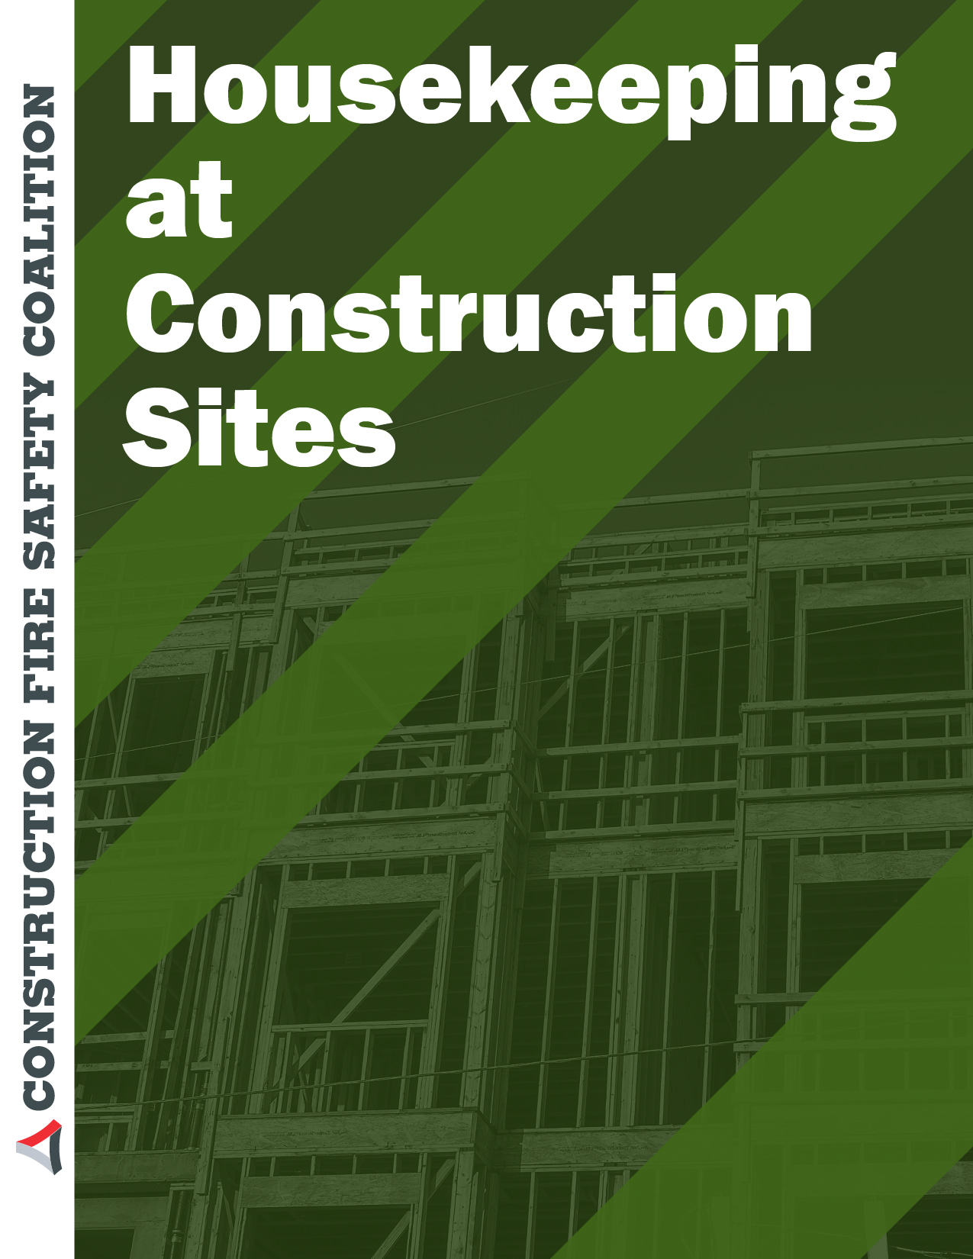

Housekeeping at Construction Sites

Summary statement: a description of the dangers of poor housekeeping suggestions on how to reduce accidents through better cleanup taken from safety sound website at North Carolina Department of Transportation
Construction sites can present many hazards to employees when they are performing construction-related activities. Keeping a construction site relatively clean of debris can further reduce hazards. The benefits of good housekeeping far exceeds the small additional effort required to establish good housekeeping practices at a construction site.

NCDOT employees on construction sites are required to practice good housekeeping to further reduce hazards on these sites. When construction hazards exist that cannot be eliminated, then engineering practices, administrative controls, safe work practices, Personal Protective Equipment (PPE), and/or proper training will be implemented.
For purposes of this OSHA standard, the following definitions apply:
- Debris: Unusable or unwanted construction waste material.
- Form Lumber: Lumber that is used to contain liquid concrete into defined shaped until the concrete hardens.
- Hazardous Wastes: Waste that is either toxic to humans or to the environment.
Scrap material and debris generated during construction usually consist of Noncombustible scrap material and debris and Combustible scrap materials and debris.

Noncombustible scrap material and debris that consist of form and scrap lumber with protruding nails, and all other debris, must be kept cleared from work areas, passageways, and stairs, and from around buildings or other structures.

Combustible scrap materials and debris must be removed at regular intervals during the course of construction without increasing the hazard exposure to employees who remove such debris. Nails should be removed from used lumber before stacking.
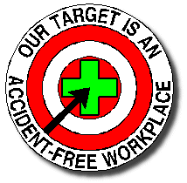All construction waste must first be collected into containers before disposal. These wastes include General Waste and Trash (nontoxic, non-hazardous) and Hazardous Wastes.
Separate containers must be provided for the collection and separation of waste, trash and other refuse.
Additional separate containers must be provided with lids for hazardous wastes to prevent sparks or other ignition sources from coming into contact with hazardous wastes. Hazardous Wastes can include used oil, used oil filters, oily rags and flammable wastes as well as caustics, acids, harmful dusts, etc.
Here is a simple checklist for Housekeeping on Construction Sites:

Construction Site:
Location:
Division/Unit:
Date:

Yes | No
 | Are protruding nails, form, scrap lumber, and other debris kept clear from work areas, passageways, and stairs, in and around buildings or other structures?
 | Are combustible scrap and debris being removed at regular intervals during the course of construction?
 | Are containers being provided for the collection and separation of waste and trash?
 | Do the containers for the hazardous wastes (oily rags and flammables) have lids?

Employees should report any hazards on the construction site to their supervisor. Hazardous wastes must be managed through your division's Hazardous Materials Manager.
Contributions Wanted!

The Safety Zone is dedicated to providing a commercial-free web site that acts as a resource of information pertaining to employee safety and health. Although sponsored by the NC Department of Transportation and focused on Transportation Safety, other safety and health related topics are included from time to time. An Archive of articles, Safety Alerts and Bulletins

are maintained for use by anyone in their efforts toward promoting employee safety and health.
To that end, we would like to offer you the opportunity to contribute your favorite safety and health related articles, bulletins, etc. for inclusion in The Safety Zone. To be accepted, they must be your original work and not copyrighted or otherwise prohibited from publication in this newsletter. Please read our DISCLAIMER below.
We want to give you an opportunity to share your safety and health information with others. That is why this space is being reserved for you. Have an Idea? Send it to the editor below:
Herbert Oxendine, CSP
Safety Engineer, NCDOT Div. 14
P. O. Box 37 Sylva, NC 28779 Courier: 08-23-15
email: hoxendine@dot.state.nc.us

www.elcosh.org

