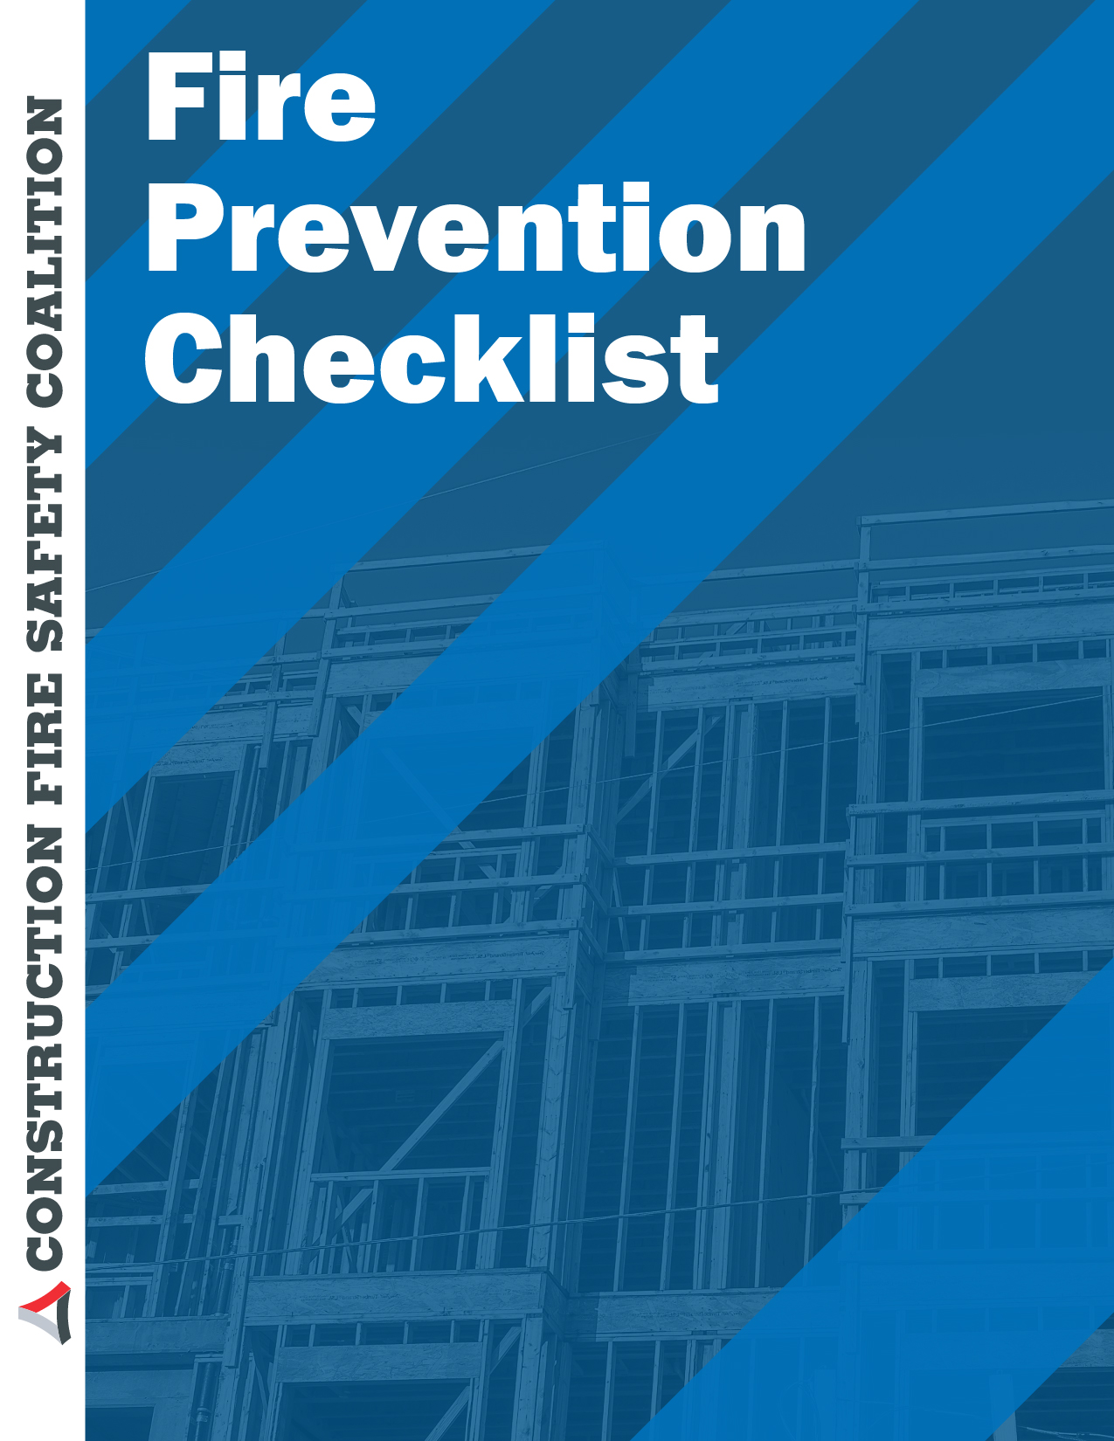
OUTLINE FOR FIRE PREVENTION ACTIVITY

Background

Buildings under construction present unique fire exposures that require special attention. Fires can result in major losses and long delays in the completion of the project. Compliance with Model Codes and NFPA standards reduces the possibility of a fire. Moreover, compliance with this checklist may reduce loss even if a fire occurs.

Factors that should be considered in a fire prevention and protection program for buildings under construction include:

ACCOUNTABILITY

Yes No N/A
The owner has designated a person to be a fire prevention program superintendant?

Yes No N/A

The fire prevention program superintendant has the authority to enforce the provisions of Model Code and NFPA standards, as necessary to secure the intent of these codes and standards?

Yes No N/A
Where guard service is provided superintendant is responsible for the guard service?

PRE-FIRE PLANNING

Yes No N/A

The fire prevention program superintendant shall develop and maintain an approved pre-fire plan in cooperation with the local authority having jurisdiction (AHJ), including building and fire?

Yes No N/A

The AHJ, including the fire code official are to be notified of any changes effecting the utilization of information contained in those plans?

TRAINING

Yes No N/A

The training of qualified and competent personnel is the responsibility of the fire prevention program superintendant?

Yes No N/A
There shall be a method of identifying individuals who have completed this training?

WATER SUPPLY
Yes No N/A

An approved water supply for fire protection either temporary or permanent, shall be made availed as soon as combustible material arrive on the site?

Yes No N/A
Care must be taken to prevent any blocking or obscuration of water supply for the building?

Yes No N/A

When hydrants are installed they should be in service prior to combustibles accumulating on site?

Yes No N/A Yes No N/A

Due to visibility issues hydrants should be flagged by a vertical 2x4 painted red identifying their location?

Any impairment to the water supply, to automatic sprinkler systems must be addressed immediately?

Yes No N/A

Where fire hydrants are subject to impact by motor vehicles, guard posts or other means of protection should be provided?

SITE ACCESS

Yes No N/A

The address numbers of the property and lot numbers or project location shall be plainly visible or legible fronting the property at the fire apparatus access point or as otherwise approved?

Yes No N/A
Are access roads of sufficient width and clearance for fire department use?

Yes No N/A

Vehicle access shall be provided by either temporary or permanent roads, capable of supporting vehicle loading of fire apparatus?

Yes No N/A

The recommendation is that the roadway should consist of compacted sub-base and six (6) inches of road base material (class 2 aggregate base rock) both compacted to a minimum of 95% of maximum grades of 15%?

Yes No N/A
Grades that exceed 15% shall be paved?

Yes No N/A
There should be a minimum of 14ft to allow aerial apparatus to maneuver in the area?

Yes No N/A

Dead end fire access roads in excess of 150ft in length shall be proved with approved turnarounds?

Yes No N/A
Approved vehicle access for firefighting shall be proved within 100ft of access to the building?

Yes No N/A

Security fences and gates shall not be placed across fire apparatus access roads without approval of the fire department?

EMERGENCY REPORTING

Yes No N/A

A readily accessible emergency telephone shall be provided in an approved location at the construction site. The street address of the construction site and the emergency telephone number of the fire department shall be posted adjacent to the telephone.?

TEMPORARY HEATING EQUIPMENT

Yes No N/A

All devices shall be listed and labeled with the International Mechanical Code or the International Fuel Gas Code?

Yes No N/A

Installation, maintenance and use of all temporary heating devices shall be in accordance with the terms of the listing?

Yes No N/A

Fuel supplies for LP gas fired heaters shall comply with Chapter 38 of the International Fuel Gas Code?

Yes No N/A

The use of temporary heating devices shall be supervised and maintained by competent personnel only?

SMOKING

Yes No N/A
Smoking shall be prohibited unless in approved areas?

Yes No N/A
Approved areas must be clearly designated?

Yes No N/A
Appropriate signs will be posted in accordance with physical layout of the site?

MOTORIZED EQUIPMENT

Yes No N/A
Equipment shall be located so that exhausts do not discharge against combustible material?

Yes No N/A
Exhausts shall be piped to the outside of the building?

Yes No N/A
Equipment shall not be refueled while in operation?

Yes No N/A
Fuel for equipment shall be stored in an approved area outside of the building?

INCENDIARISM AND ARSON

Yes No N/A
Are all exterior areas of the property illuminated?

Yes No N/A
Is the perimeter of the property protected by a fence?

Yes No N/A

Are trees and vegetation cut back to provide a clear space of at least 100ft (30.4m) clearance around the perimeter of the property?

Yes No N/A
Are combustible materials and trash in yard areas removed on a regular basis?

HOT WORK OPERATIONS

Yes No N/A
Is a hot-work permit system used for all cutting, welding, and soldering operations?

Yes No N/A

Is hot-work equipment, including torches and fuel/gas cylinders, regularly inspected and serviced?

Yes No N/A

Are portable gas cylinders used in welding and cutting operations stored and used in accordance with NFPA 55, Standard for the Storage, Use, and Handling of Compressed and Liquefied Gases in Portable Cylinders, published by the National Fire Protection Association (NFPA)?

Yes No N/A

Are multi-purpose, portable fire extinguishers kept nearby whenever hot-work operations are undertaken?

Yes No N/A

Is a fire watch provided during hot-work operations and for at least one hour after operations have been completed?

HOUSEKEEPING

Yes No N/A

Are good housekeeping practices followed, including routine cleaning of dust over 1/8 in (3.18mm) in depth from all surfaces?

Yes No N/A
If smoking is allowed on the premises, is it restricted to certain areas?

Yes No N/A

Are storage rooms, trash rooms, inside dumpsters, and similar areas separated from other areas by one-hour fire barriers or protected by automatic sprinklers?

UTILITIES

Yes No N/A

Are electrical appliances that are used in areas where flammable atmospheres are present listed/approved for such use by a nationally recognized testing laboratory, such as Underwriters Laboratories, Inc (UL?)?

Yes No N/A

Are electrical systems that are installed where flammable liquids are stored or dispensed listed/ approved for Class I, Division 2 locations?

Yes No N/A

Is electrical equipment that is used in wet areas, such as restrooms and outside locations, provided with ground fault protection, including the use of isolated power supplies?

Yes No N/A
Is gas and oil fired equipment maintained according to the manufacturers' recommendations?

Yes No N/A
Are wood fired boilers present?

Yes No N/A
Are temporary heating devices operated in accordance with recommended safe practices?

FLAMMABLE AND COMBUSTIBLE LIQUIDS

Yes No N/A

The storage, use and handling of flammable and combustible liquids at construction sites shall be in accordance with the International Fire Code. Ventilation shall be provided for operations involving the application of materials containing flammable solvents?

Yes No N/A

Flammable and combustible liquid storage areas shall be maintained clear of combustible vegetation and waste materials. Such storage areas shall not be used for the storage of combustible materials?

Yes No N/A

Sources of ignition and smoking shall be prohibited in flammable and combustible liquid storage areas. Signs shall be posted in accordance with the International Fire Code?

Yes No N/A
Flammable and combustible liquids shall be kept in approved safety containers?

Yes No N/A

Leaking vessels shall be immediately repaired or taken out of service and spills shall be cleaned up and disposed of properly?

DISPENSING OF FUELS

Yes No N/A
Are flammable liquids and gases stored in containers that are listed/approved for such use?

Yes No N/A

Is equipment using gasoline or diesel fuel stored in a separate, detached building or in a room segregated from storage areas by firewalls or fire barriers and automatic closing fire doors?

Yes No N/A

Are refueling operations performed by trained and designated personnel, and only in specified, well-ventilated areas?

Yes No N/A

Is proper bonding/grounding provided before transferring flammable liquids into portable containers or equipment fuel tanks?

STORAGE

Yes No N/A

If compressed gases stored on site, are they stored in a separate area, away from ignition sources, and secured to prevent tipping and damage?

Yes No N/A

If blasting operations are performed, are explosives stored according to recommend practices?

Yes No N/A

Is lumber that is used for framing and forms stored in separate facilities, preferably in an outside location?

Yes No N/A
Is lumber stored in the horizontal plane and wrapped in tight bundles?

FIRE PROTECTION

Yes No N/A

Is there a sufficient number of listed/approved portable fire extinguishers, and are they properly located and maintained, as required in NFPA 10, Standard for Portable Fire Extinguishers or in compliance with Model Code?

Yes No N/A
Are employees trained in the use of portable fire extinguishers?

Yes No N/A

Are fire alarms, detectors, and fixed fire protection, such as automatic sprinklers, installed in temporary structures?

Yes No N/A

In buildings in four or more stories in height, there should be at least one standpipe for use by fire department during construction?

