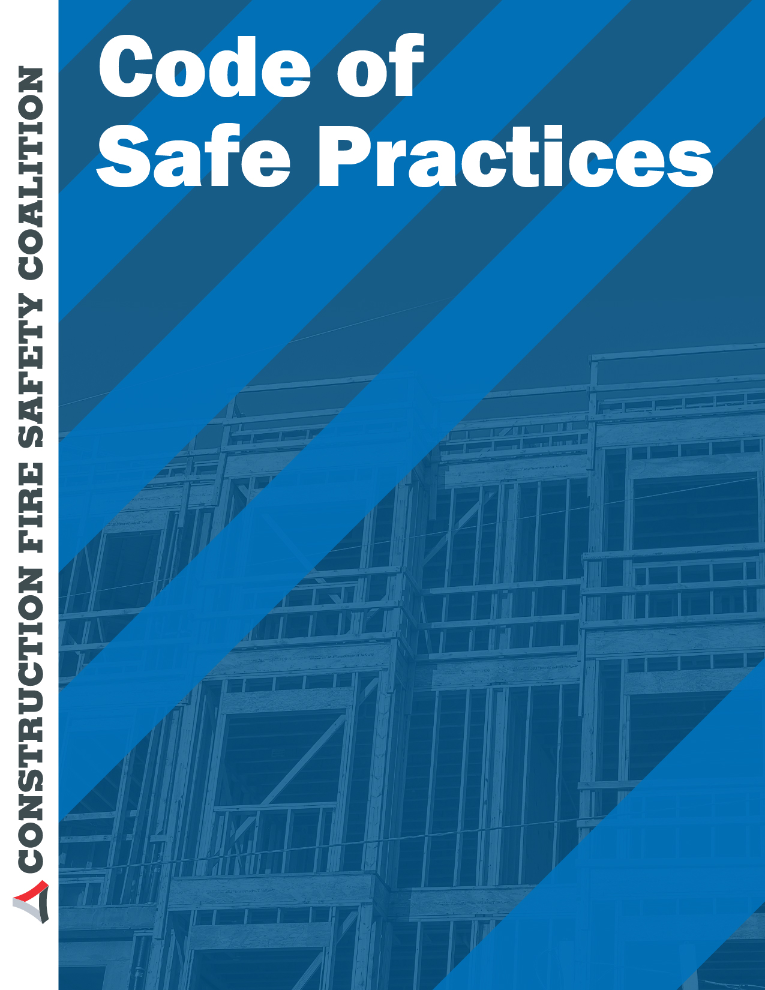

Insert Company Name & logo here

CODE OF SAFE PRACTICES (Sample Two)

(This is a suggested format. It is general in nature and intended as a basis for the preparation of a code of safe practices by the entity that will fit its operations closely.)

General

1. All persons shall follow these safe practice rules, render every possible aid to safe operations, and report all unsafe conditions or practices to the supervisor or superintendent.

2. Supervisors shall insist on employees observing and obeying every applicable Local, State or Federal regulation and order as is necessary to the safe conduct of the work, and shall take such action as is necessary to obtain compliance.

3. All employees shall be given frequent Injury and Illness Prevention Plan (IIPP) instructions. Instructions shall be given at least every 10 working days.

4. Anyone known to be under the influence of drugs or intoxicating substance which impair the employee’s ability to safely perform the assigned duties shall not be allowed on the job while in that condition.

5. Horseplay, scuffling, and other acts which tend to have an adverse influence on the safety or well-being of the employees shall be prohibited.

6. Work shall be well planned and supervised to prevent injuries in the handling of materials and in working with equipment.

7. No one shall knowingly be permitted or required to work while the employee’s ability or alertness is so impaired by fatigue, illness, or other causes that they might unnecessarily expose the employee or others to injury.

8. Employees shall not enter confined spaces unless it has been determined that it is safe to enter. An entry permit shall be completed before entry into permit-required spaces.

9. Employees shall be instructed to ensure that all guards and other protective devices are in proper places and adjusted, and shall report deficiencies promptly to the supervisor or superintendent.

10. Crowding or pushing when boarding or leaving any vehicle or other conveyance shall be prohibited.

11. Workers shall not handle or tamper with any electrical equipment, machinery, or air or water lines in a manner not within the scope of their duties, unless they have received instructions from their superintendent.

12. All injuries shall be reported promptly to the supervisor or superintendent so that arrangements can be made for medical or first aid treatment. All accidents shall be investigated and the findings documented. Corrective measures to prevent future accidents shall be implemented.

13. When lifting heavy objects, the large muscles of the leg instead of the smaller muscles of the back shall be used.

14. Inappropriate footwear or shoes with thin or badly worn soles must not be worn.

15. Materials, tools, or other objects shall not be thrown from buildings or structures until proper precautions are taken to protect others from the falling objects.

16. Employees shall cleanse themselves thoroughly after handling hazardous substances and follow special instructions from authorized sources.

17. Any damage to scaffolds, falsework, or other supporting structures shall be immediately reported to the supervisor and repaired before use.]

18. Work shall be so arranged that employees are able to face a ladder and use both hands while climbing.

19. Gasoline shall not be used for cleaning purposes.

20. No burning, welding, or other source of ignition shall be applied to any enclosed tank or vessel, even if there are openings, until it has first been determined that no possibility of explosion exists and authority for the work is obtained from the supervisor or superintendent.

Use of Tools & Equipment

21. All tools and equipment shall be maintained in good condition.

22. Damaged tools or equipment shall be removed from service and tagged “DEFECTIVE.”

23. Pipe or Stillson wrenches shall not be used as a substitute for other wrenches.

24. Only appropriate tools shall be used for a specific job.

25. Wrenches shall not be altered by the addition of handle-extensions or “cheaters.”

26. Files shall be equipped with handles and not used to punch or pry.

27. A screwdriver shall not be used as a chisel.

28. Wheelbarrows shall not be pushed with handles in an upright position.

29. Portable electric tools shall not be lifted or lowered by means of the power cord. Ropes shall be used.

30. Electric cords shall not be exposed to damage from vehicles.

31. In locations where the use of a portable power tool is difficult, the tool shall be supported by means of a rope or similar support of adequate strength.

Machinery & Vehicles

32. Only authorized persons shall operate machinery or equipment.

33. Loose or frayed clothing, long hair, dangling ties, finger rings, etc., shall not be worn around moving machinery or other areas where they may become entangled.

34. Machinery shall not be serviced, repaired or adjusted while in operation, nor shall oiling of moving parts be attempted, except on equipment that is designed or fitted with safeguards to protect the person performing the work.

35. Where appropriate, lock-out procedures shall be used.

36. Employees shall not work under vehicles supported by jacks or chain hoists without protective blocking that will prevent injury if jacks or hoists should fail.

37. Air hoses shall not be disconnected at compressors until the hose line has been bled.

38. All excavations shall be visually inspected before backfilling to ensure that it is safe to backfill.

39. Excavating equipment shall not be operated near tops of cuts, banks, or cliffs if employees are working below.

40. Tractors, bulldozers, scrapers and carryalls shall not operate where there is a possibility of overturning in dangerous areas like edges of deep fills, cut banks, and steep slopes.

41. When loading where there is a probability of dangerous slides or movement of material, the wheels or treads of loading equipment should be turned in the direction which will facilitate escape in case of danger, except in a situation where this position of the wheels or treads would cause a greater operational hazard.

CODE OF SAFE PRACTICES (CONSTRUCTION)

Name of Project
GENERAL

1. All employees shall follow these safe practices rules, render every possible aid to safe operations, and report all unsafe conditions or practices to their Supervisor or the Alternate Responsible Person.

2. Supervisors shall insist on employees observing and obeying all rules, regulations, and orders as is necessary to insure the safe conduct of the work, and shall take such action as is necessary to obtain observance.

3. All employees shall be given frequent accident prevention instructions. Instruction should be given at least every 30 working days.

4. Any employee known to be under the influence of drugs or intoxicating substances which impair the employee's ability to safely perform the assigned duties shall not be allowed on the job.

5. Horseplay, scuffling, and other acts which tend to have an adverse influence on the safety or well-being of the employees shall be prohibited.

6. Work shall be well planned and supervised to prevent injuries in the handling o material and in working together with equipment.

7. No employee shall knowingly be permitted or required to work while the employee's ability or alertness is so impaired by fatigue, illness, or other causes that it might unnecessarily expose the employee or others to injury.

8. Employees shall not enter manholes, underground vaults, chambers, tanks, silos, crawlspaces, or other similar places that receive little ventilation, unless it has been determined that it is safe to enter.

9. Employees shall be instructed to ensure that all guards and other protective devises are in proper places and adjusted, and shall report deficiencies promptly to the Supervisor or Alternate Responsible Person.

10. Crowding or pushing when boarding or leaving any vehicle or other conveyance shall be prohibited.

11. Employees shall not handle or tamper with any electrical equipment, machinery, or air or water lines in manner not within the scope of their duties, unless they have received instructions from their Supervisors.
12. All injuries shall be reported promptly to the Supervisors or the Alternate Responsible Person so that arrangement can be made for medical or first aid treatment.

13. When lifting heavy objects, use the large muscles of the leg instead of the smaller muscles of the back.

14. Inappropriate footwear or shoes with thin or badly worn soles shall not be worn.

15. Material, tools, or other objects shall not be thrown from buildings or structures until proper precautions are taken to protect others from the falling objects.

16. Employees shall cleanse thoroughly after handling hazardous substances, and follow special instruction from authorized sources.

17. Hod carriers should avoid the use of extension ladders when carrying loads. Such ladders may provide adequate strength, but the rung position and rope arrangement may make such climbing difficult and hazardous for this trade.

18. Work shall be so arranged that employees are able to face ladder and use both hands while climbing.

19. Gasoline shall not be used for cleaning purposes.

20. No burning, welding, or other source of ignition shall be applied to any enclosed tank or vessel, even if there are some openings, until it has first been determined that no possibility of explosion exists, and authority for the work is obtained from the Supervisors or Alternative Responsible Person.

21. Any damage to scaffolds, falsework, or other supporting structures shall be immediately reported to the supervisor or Alternate Responsible Person, and repaired before use.

USE OF TOOLS & EQUIPMENT

1. All tools and equipment shall be maintained in good condition.

2. Damaged tools or equipment shall be removed from service and tagged "DEFECTIVE."

3. Pipe or Stillson wrenches shall not be used as a substitute for other wrenches.

4. Only appropriate tools shall be used for the job.

5. Wrenches shall not be altered by the addition of handle-extensions or "cheaters."

6. Files shall be equipped with handles and not used to punch or pry.

7. A screwdriver shall not be used as a chisel.
8. Wheelbarrows shall not be pushed with handles in an upright position.

9. Portable electric tools shall not be lifted or lowered by means of the power cords. Robes shall be used.

10. Electric cords shall not be exposed to damage from vehicles.

11. In locations where the use of a portable power tool is difficult, the tool shall be supported by means of a rope or similar support of adequate strength.

MACHINERY & VEHICLES

1. Only authorized employees shall operate machinery or equipment.

2. Loose or frayed clothing, or long hair, dangling ties, finger rings, etc. shall not be worn around moving machinery or other sources of entanglement.

3. Machinery shall not be serviced, repaired or adjusted while in operation, nor shall oiling of moving parts be attempted, except on equipment that is designed or fitted with safeguards to prot3ect the employee performing the work.

4. Where appropriate, lock-out procedures shall be used.

5. Employees shall not work under vehicles supported by jacks or chain hoists, without protective blocking that will prevent injury if jacks or hoists should fail.

6. Air hoses shall not be disconnected at compressors until hose line has been bled.

7. All excavating shall be visually inspected before backfilling, to ensure that it is safe to backfill.

8. Excavating equipment shall not be operated near tops of cuts, banks, and cliffs if employees are working below.

9. Tractors, bulldozers, scrapers and carry all shall not operate where there is possibility of overturning in dangerous areas like edges of deep fills, cut banks, and steep slopes.

10. When loading where there is a probability of dangerous slides or movement of material, the wheel or treads of loading equipment, other than that riding on rails, should be turned in the direction which will facilitate escape in case of danger, except in a situation where this position of the wheels or treads would cause a greater operational hazard.

ROOFING OPERATIONS

1. Knotted hand lines should not be used.

2. Roofers tending kettles, or carrying buckets of hot tar, shall wear gloves that fit snugly at the wrists, and long sleeved shirts fastened at the wrists.

3. At no time should a roofer, while handling or exposed to injury from hot tar, work without a shirt or appropriate footwear.

4. Appropriate portable fire extinguishers shall be kept at or near the kettle, attached, if practicable, to the tongue of the kettle, away from the danger zone.

5. Kettle covers should be equipped with a handle that projects at least fourteen (14) inches away from the surface of the cover or lid.

6. Kettle covers shall be closed and latched when in transit and the kettle should be slop-proof when cover is closed.

7. When parked, means shall be provided to prevent inadvertent movement of the kettle.

8. Ladders should be used with great caution, and roof gutters should not be depended upon for support.

9. Workers handling buckets of hot tar should not carry anything that will interfere with the safety of this operation.

10. The gallows frame shall be securely anchored before hoisting materials.

11. Only muscular power shall be used to hoist materials by means of a gallows frame. A winch or power hoist shall not be used.

For additional information on Model documents that may assist you, use the following websites:

ycparmia.org/policysafecode
http://bfa.sdsu.edu/ehs/pdf/Attachment6.pdf
http://www.ghilotti.com/subcontract-docs/subcontractpdf/Code%20of%20Safe%20Practicesfnl.pdf
https://www.google.com/#q=code+of+safety+practices+for+construction
http://gs-construction.com/filesafe/652_Safe_Practices.pdf
https://www.google.com/#q=code+of+safe+practices
http://www.labour.gov.hk/eng/public/os/manage.pdf
http://www.osha.com/
http://gs-construction.com/filesafe/652_Safe_Practices.pdf

