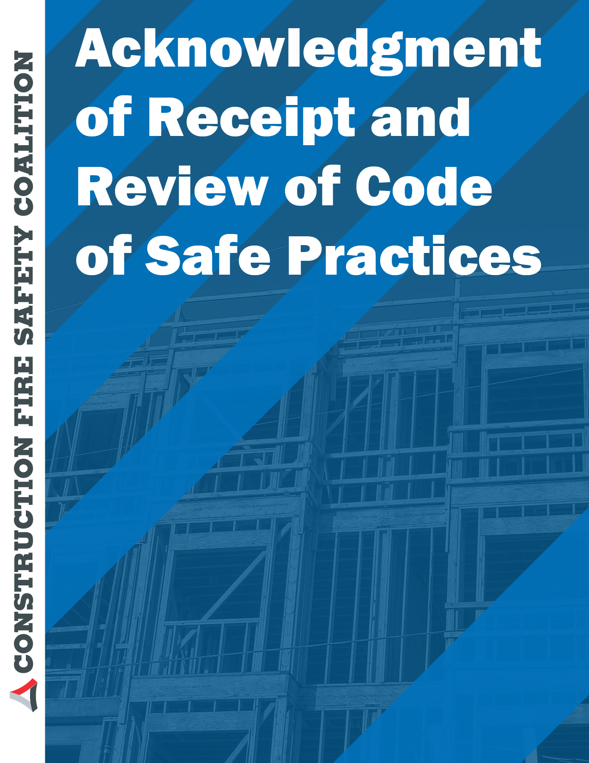

If a company has adopted a Code of Safe Practice they should have each employee sign a receipt that they have read and will comply with the code. If you do not already have your own, the following format might useful.

Acknowledgment of Receipt
and Review of
(insert company name here)
Code of Safe Practices
To all employees:
Attached is a copy of the Code of Safe Practices for our company. These guidelines are provided for your safety. It is the responsibility of:_________________________________________
Manager or Supervisor

to provide and review this code with each employee. It is the employee's responsibility to read and comply with this code. Attached copy of the code of safe practices order are for you to keep. Please sign and date below and return this page only to
______________________________________________________________________________
Name

- - - - - - - - - - - - - - - - - - - - - - - - - - - - - - - - - - - - - - - - - - - - - - - - - - - - - - - - - - - - - - - - - - - - - - - - - - - - - - -
I have read and I understand the code of safe practices
____________ _________________________________________________________________
Date Employee Print Name
_________________________________________________________________
Employee Signature

